

Lập trình toàn năng
Training Assignments
Program Code
Issue/Revision
Effective date
Author
- Select one answer for each question.

Questions & answers
1. MySQL is a(n) _________ database management system ?
- Object oriented
- Hierarchical
- Relational
- Network
2. What is the data in a MySQL database?
- Objects
- Tables
- Networks
- File systems
3. The AUTO_INCREMENT sequences normally begin at __________?
- 0
- 1
- -1
- 2
4. The datatype SMALLINT stores ___________?
- 16 bit
- 32 bit
- 48 bit
- 8 bit
5. You have a table named Employees. You want to identify the supervisor to which
each employee reports. You write the following query.
SELECT e.EmloyeeName AS [EmployeeName], s.EmployeeName AS [SuperVisorName]
FROM Employees e
You need to ensure that the query returns a list of all employees and their respective
supervisor. Which join clause should you use to complete the query?
- RIGHT JOIN Employees s ON e.ReportsTo = s.EmployeeId.
- LEFT JOIN Employees s ON e.ReportsTo = s.EmployeeId.
- INNER JOIN Employees s ON e.EmployeeId = s.EmployeeId.
6. A function returns one value and has only output parameters?
- TRUE
- FALSE
7. To create a database only if it doesn’t already exist, which clause is used?
- IF EXISTS.
- IF NOT EXISTS
- CREATE EXISTS
- EXISTS IF
8. Which SQL gain table B from table A?
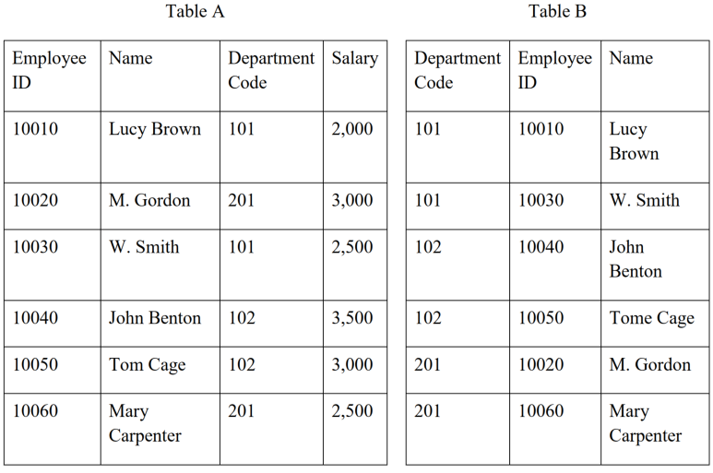
- SELECT department_code, employee_ID, name
FROM A
GROUP BY employee_ID;

- SELECT department_code, employee_ID, name
FROM A
GROUP BY department_code;

- SELECT department_code, employee_ID, name
FROM ASoftware Developer Entry Test Page 2 of 9
ORDER BY employee_ID;

- SELECT department_code, employee_ID, name
FROM A
ORDER BY department_code.
9. Which Numeric Data type has the largest range?
- Mediumint
- Smallint
- Int
- Tinyint
10. What is the default format for “Date” data type?
- YYYY-MM-DD
- MM-YYYY-DD
- DD-MM-YYYY
- None of the mentioned
11. Which of the following conditions has to be satisfied for INNER JOIN to work?
- Columns used for joining must have same name.
- Columns used for joining can have same or different name.
- Columns used for joining must have different names.
- Columns used for joining must have different names.
12. A View can be used to select a subset of the table columns?
- True
- False
13. What is abc in the following MySQL statement?
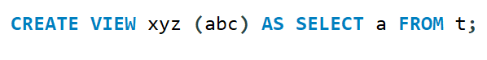
- row name
- column name
- view
- database
14. A view can refer to multiple tables via __________?
- UNION
- JOIN
- GROUP
- SELECT
15. Views are not updatable?
- True
- False
16. Which procedure parameter enables the caller to pass in a value and get back a value?
- IN
- OUT
- IN OUT
- GETINOUT
17. Which of these is defined to execute when the table is modified only?
- Stored functions.
- Stored procedures.
- Triggers.
- Events.
18. There is a table including the data items shown below. Which of the following SQL statements can insert a new row in the “student” table?
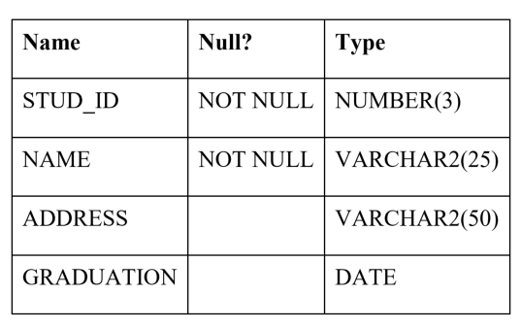
- INSERT INTO student (stud_id, address, graduation)
VALUES (101, ‘Dave’, ‘100 Happy Lane’, ‘2001-06-14’);

- INSERT INTO student (stud_id, address, name, graduation)
VALUES (101, ‘100 Happy Lane’, ‘Dave’, ‘2001-06-14’);

- INSERT INTO student
VALUES (101, ‘100 Happy Lane’, ‘2001-06-14’, ‘Dave’);

- INSERT INTO student
VALUES (101, ‘2001-06-14’, ‘100 Happy Lane’, ‘Dave’);
19. Which clause is used to sort the result by one or more columns?
- HAVING
- FROM
- ORDER BY
- WHERE
20. How many values can be returned from a given stored function?
- 0
- 1
- 2
- 3
21. How many values can be returned from a stored procedure?
- 0
- 1
- 2
- 3
22. Which procedure parameter enables the caller to pass in a value and get back a value?
- IN
- OUT
- IN OUT
- GETINOUT
23. How many rows are included in the table gained as as result of execution of the following statement?
SELECT DISTINCT customer_name, merchandise_name, unit_price
FROM order_table, merchandise_table
WHERE order_table.merchandise_number = merchandise_table.mnrchandise_number;
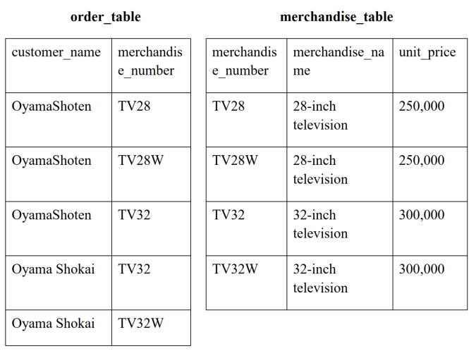
- 2.
- 3.
- 4.
- 5.
24. For which of the following are triggers not supported?
- delete
- update
- insert
- views
25. Which statement is used to remove a trigger?
- REMOVE
- DELETE
- DROP
- CLEAR
26. Which of the following SQL statements can extract employee name’s whose salary is
$10000 or higher from the table “human_resource”?
- SELECT salary
FROM human_resourceSoftware Developer Entry Test Page 6 of 9
WHERE employee_name >=10000
GROUP BY salary
- SELECT employee_name, COUNT(*)
FROM human_resource
WHERE salary>=10000
GROUP BY employee_name
- SELECT employee_name, salary
FROM human_resource
GROUP BY salary
HAVING COUNT(*)>=10000.
- SELECT employee_name
FROM human_resource
WHERE salary>=10000.
27. Which Numeric Data type has the largest range?
- Mediumint
- Smallint
- Int
- Tinyint
28. Trigger is special type of __________ procedure?
- Function
- Stored
- View
- Table
29. How can we specifies a row-level trigger?
- Using ON ROW
- Using FOR EACH COL
- Using FOR EACH ROW
- Using OR ROW
30. Your database contains two tables named DomesticSalesOrders and
InternationalSalesOrders. Both tables contain more than 100 million rows. Each table
has a Primary Key column named SalesOrderId. The data in the two tables is distinct
from one another. Business users want a report that includes aggregate information
about the total number of global sales and total sales amounts. You need to ensure that
your query executes in the minimum possible time. Which query should you use?
- SELECT COUNT(*) AS NumberOfSales, SUM(SalesAmount) AS TotalSalesAmount
FROM (
SELECT SalesOrderId, SalesAmount
FROM DomesticSalesOrders
UNION ALL
SELECT SalesOrderId, SalesAmount
FROM InternationalSalesOrders
) AS p;

- SELECT COUNT(*) AS NumberOfSales, SUM(SalesAmount) AS TotalSalesAmount
FROM (
SELECT SalesOrderId, SalesAmount
FROM DomesticSalesOrders
UNION
SELECT SalesOrderId, SalesAmountSoftware Developer Entry Test Page 7 of 9
FROM InternationalSalesOrders
) AS p;

- SELECT COUNT(*) AS NumberOfSales, SUM(SalesAmount) AS TotalSalesAmount
FROM DomesticSalesOrders
UNION
SELECT COUNT(*) AS NumberOfSales, SUM(SalesAmount) AS TotalSalesAmount
FROM InternationalSalesOrders;

- SELECT COUNT(*) AS NumberOfSales, SUM(SalesAmount) AS TotalSalesAmount
FROM DomesticSalesOrders
UNION ALL
SELECT COUNT(*) AS NumberOfSales, SUM(SalesAmount) AS TotalSalesAmount
FROM InternationalSalesOrders;

